In the holidays there is nothing better than relaxing with a good book.
This summer, we dare you to take part in our EXTREME READING CHALLENGE!!!

What is the strangest or most unusual place you can be photographed reading?
Perhaps you can take up reading on a tractor or upside down or maybe on top of a climbing frame!

You can read ANYTHING! Newspapers, comics, books, recipes, magazines, fact books, seed packets, leaflets, holiday brochures, tourist information, timetables, posters, cereal packets, song lyrics, newsletters etc..
Be inventive!

Obviously, we encourage you to keep safe (I wouldn’t recommend reading in the jaws of a crocodile!) but we are really looking forward to seeing who in school has such a passion for reading that they have to do it anywhere and everywhere!

Bring in your photographs to your class teacher after the holidays and the most unusual or extreme reading place photos will be displayed in the school entrance hall! There will also be a prize for the most unusual photo in each Key Stage!
We hope you have a lovely and relaxing break and we look forward to seeing your Extreme Reading Challenge photos when we return in September!

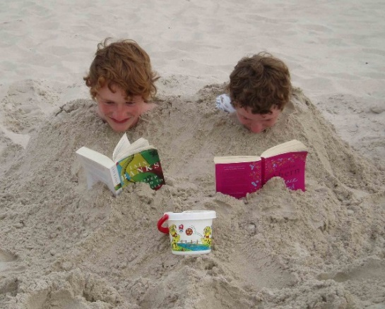

Yours sincerely

A Clayton
Headteacher

