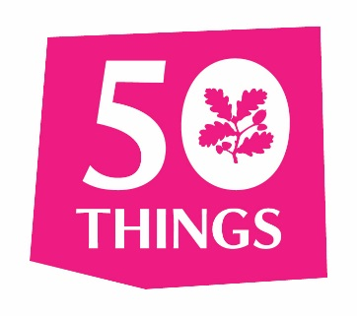
25 Things To Do Before
You’re 7¾

Adventurer
- Climb a tree
- Roll down a really big hill
- Skim a stone
- Run around in the rain
Ranger
- Go on a walk barefoot
- Make a grass trumpet
- Hunt for fossils or bones
- Go star gazing
- Hold a scary beast

Discoverer
- Make a trail with sticks
- Make a mud pie
- Dam a stream
- Make a daisy chain
- Create some wild art
- Play pooh sticks

Tracker
- Hunt for bugs
- Catch a falling leaf
- Make a home for a wild animal
- Bring up a butterfly
- Go on a nature walk at night

Explorer
- Plant it, grow it, eat it
- Go swimming in the sea
- Build a raft
- Go bird watching
- Find your way with a map and compass
Sign up online to get your own explorer, plus top tips, extra challenges
www.50things.org.u

